**Unit I**

1. Explain the terms:
2. Class
3. Object
4. Polymorphism
5. Encapsulation
6. Inheritance
7. Explain various loops used in JAVA and also write a program to calculate the following sum: 5+10+15+20+…..+100
8. Describe various data type supported in JAVA with an example.
9. Explain an Operator? Write a program for Boolean Operator.
10. Explain steps for executing a Java program. Also write simple JAVA program to display “Hello World”.
11. Write a java program to print the square of first 10 even numbers.
12. Write a program to find largest number amongst the three numbers using conditional or ternary operator.
13. Write an application program in java to Swap Two Numbers Using Third Variable.
14. Explain widening and narrowing in the context of Java primitive date type conversion.
15. Write a Java Program to Check Whether the Character is Vowel or Consonant using IF-ELSE.
16. Differentiate between procedural language and object oriented language?

**Unit II**

1. What is Constructor? Explain constructor overloading with an example.
2. Explain the use of "this” keyword with an example.
3. What is an array? Write a program in java to sort elements of given array in ascending order.
4. Write a program to define class and object.
5. Explain the difference between instance variable, local variables and static variables with an example.
6. Write a class student having data members name, roll_no and branch of student. Declare one constructor to initialize above data members and one display() method to display the information of a single student.
7. Describe the “this” keyword to call a constructor from another constructor with an example.
8. Write a JAVA program to demonstrate method overloading.
9. Write a Java program that creates an object and initializes its data members using constructor.
10. What is command line arguments? Explain with example.

**Unit III**

1. What is inheritance? Explain different types of inheritance in detail.
2. Explain final method and final class with example.
3. Differentiate between abstract class and abstract method.
4. what is multilevel hierarchy? Explain with an example. How it is implemented in java?
5. What is method overriding? Explain with an example.
6. Explain in detail about:
7. Packages
8. Enum Type
9. Differentiate between :- (i) Abstract class and abstract method. (ii) Super and this keyword
10. Explain about :- (i) Final keyword. (ii) Final method. (iii) Final class.
11. What is inheritance? Explain and demonstrate multiple inheritance with an example
12. What is package Explain the procedure for creating user defined package in java
13. Create a class named 'Member' having the following members:  
    Data members  
    1 - Name  
    2 - Age  
    3 - Salary  
    It also has a method named 'printSalary' which prints the salary of the members.  
    Two classes 'Employee' and 'Manager' inherits the 'Member' class. The 'Employee' and 'Manager' classes have data members 'specialization' and 'department' respectively. Now, assign name, age, and salary to an employee and a manager by making an object of both of these classes and print all the respective data members of the classes.
14. Write a program for implementing the following requirement:

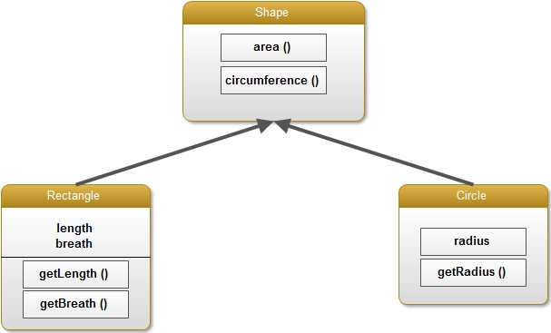

1. What is an interface? Explain with an example. Differentiate it with an abstract class
2. Explain abstract classes with an example.

**Unit IV**

1. Write a Java program that handles multiple exception.
2. List out various methods associated with file objects and explain with an example.
3. Write a Java program to read character stream using File Reader.
4. Explain the following terms: — (i). try (ii) catch (iii) throw (iv) throws (v) finally (vi) exceptions.
5. Write a java program to write the data into a file using file output stream.
6. Explain checked and unchecked Exception. List out them
7. What is Random Access File? Explain the methods of it
8. Write a program to create and delete a file object.
9. Write a java program to write the data into a file using File Writer class.
10. What is, Exception handling mechanism? Write an application which handles, arithmetic and Array Index Out of Bound Exception.
11. List out the various methods associated with file objects and explain with an example
12. Write a program that creates a text file called test.txt and writes on it the string "some text written on a file".
13. Write a java program to read the contents of a file byte by byte and copy it into another file. Get the names of the files from user through standard input.
14. Explain about, Buffered Input Stream and Buffered Output Stream with an example.

**Unit V**

1. Explain the life cycle of an applet in detail.
2. Write a program to display string on appletviewer and rectangle using drawRect() method.
3. Explain in detail about:
4. getDocumentBase()
5. getCodeBase()
6. Differentiate the following:
7. applet and application
8. drawOval() and drawRect()
9. What is an applet? How does it differ from an application and also explain life cycle of an applet.
10. Write an applet program to draw circle using drawOval() method and also display the string “SGBAU” inside the circle.
11. Explain applet tag in detail.
12. Differentiate between:
13. paint() and repaint() methods
14. applications and applets
15. Write a program to pass employee name and id number to an applet.

**Unit VI**

1. Write a program to create checkbox
2. Explain delegation event model with an example
3. Explain following terms:
4. Adapter classes
5. Inner classes
6. Write a program to create a list on appletviewer.
7. Write an applet program to draw two button objects with label as Red and Green, when user click on a particular button then background color will be change.
8. Write a program to demonstrate the key event handlers.
9. Write a Java Application to create a file menu with menu items like New, Open, Save, Print and Close.
10. Explain Mouse Listener and mouse motion listener interface in event delegation model.